Screenshots:

1. Upon execution, my name is displayed and the test 1 banner signifies that the first three heuristics will be organizing char lists:  
     
   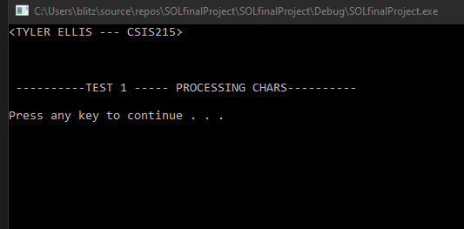
2. Pressing a key will display the results of the count heuristic:  
   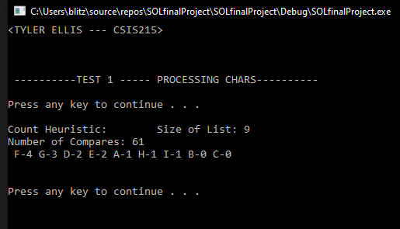
3. Pressing a key will show the Move to front heuristic:  
     
   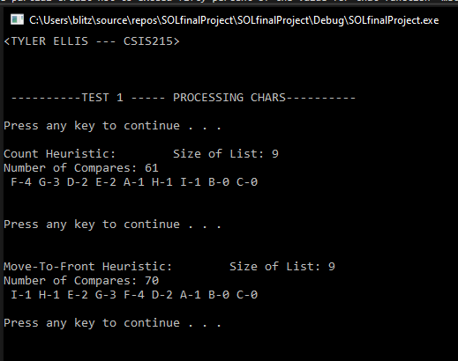
4. Pressing a key once again will display the transpose heuristic:  
     
   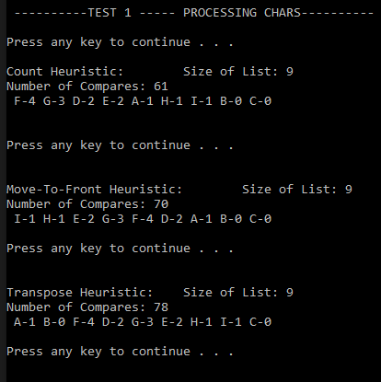
5. Now that Test 1 has concluded, pressing a key will show the information for the three heuristics, one at a time, but with the string inputs:  
     
   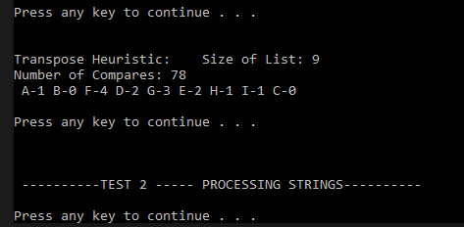
6. First, the count data:  
     
   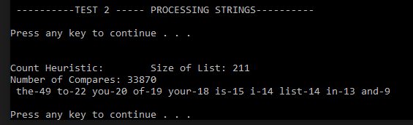
7. Move-to-front:  
     
   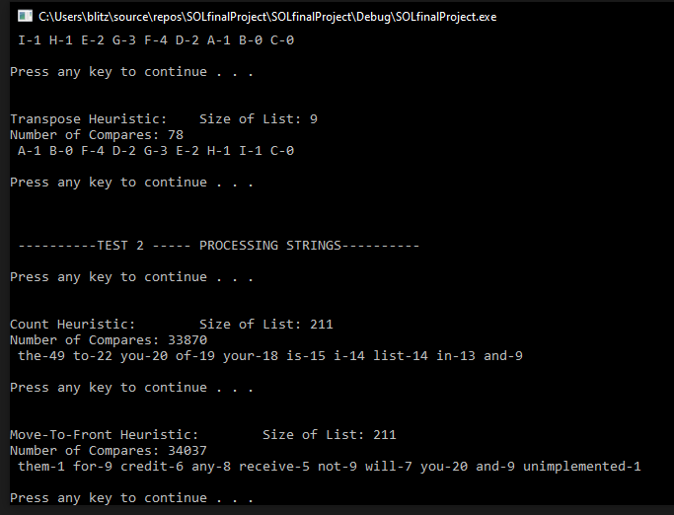
8. And lastly, the transpose:  
     
   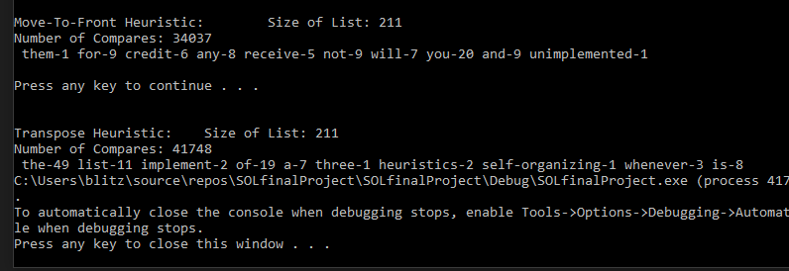

STATEMENTS

* I declare that this code I have added to the files downloaded from the assignment instructions is my own, original work, and that all lines of code were written exclusively by me.
* If requested by my instructor, I can provide sources for all resources I used in completing the assignment.
* I did not knowingly modify this assignment in an effort to defeat/beat the assignment expectations.